**SOLUTION PROCESS**

1. Use Case: A primary look at the data on how many different kinds of criminal activities has occurred on 15th January 2018

Query: SELECT *

FROM crime_scene_report

WHERE date=20180115

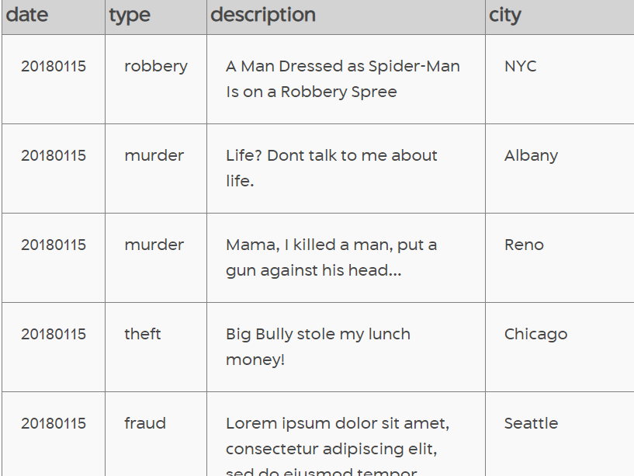

1. Use Case: Categorising the criminal activities into murder.

Query: SELECT *

FROM crime_scene_report

WHERE date=20180115

AND type="murder"

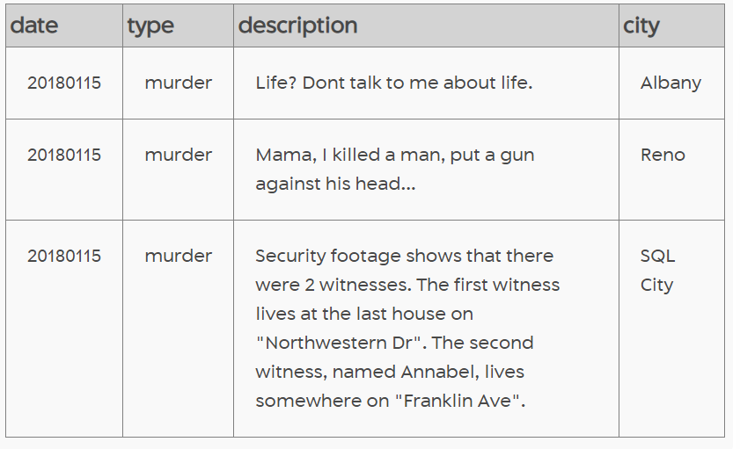

1. Use Case: We understood that there were two witnesses. We are trying to get more information on the witnesses.

Query: SELECT *

FROM person

WHERE address_street_name

LIKE "Franklin ave"

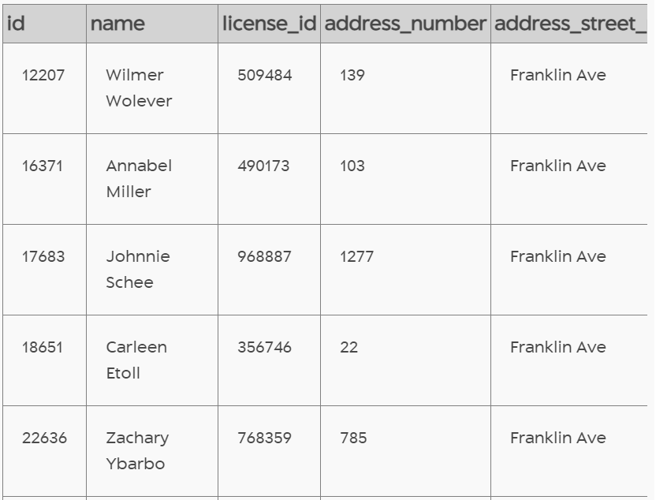

1. Use Case: We are trying to find the details of the other witness. Since the person lives on the last house of Northwestern Dr, we can find it through arranging address number in descending order.

Query: SELECT *

FROM person

WHERE address_street_name

LIKE "northwest%"

ORDER BY

address_number DESC

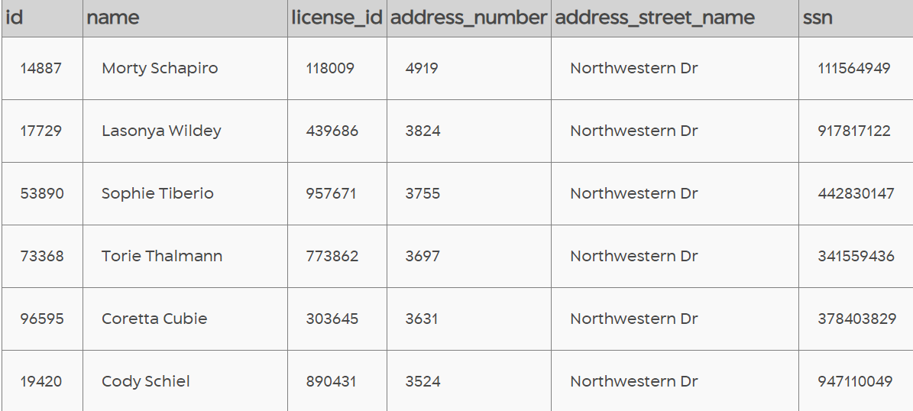

1. Use Case: We need interview tapes from the witnesses. First, we look into what Annabel said by checking with her person id.

Query: SELECT *

FROM interview

WHERE

person_id=16371

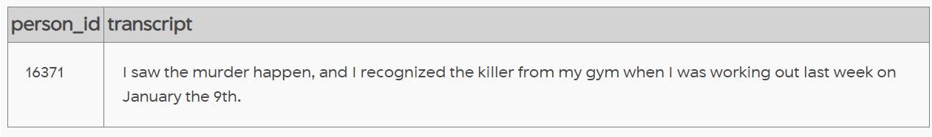

1. Use Case: Now we look into what Morty said by checking it with her person id.

Query: SELECT *

FROM interview

WHERE

person_id=14887

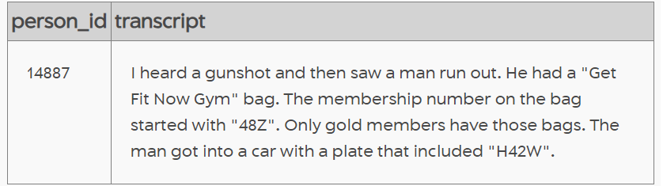

1. So, with this peace of information, we are filtering down to people who have “get fit now” bags in the gym. We are joining members table and get fit check in table.

Query: SELECT *

FROM get_fit_now_check_in

JOIN get_fit_now_member

ON get_fit_now_check_in.membership_id=get_fit_now_member.id

WHERE membership_id

LIKE "48Z%"

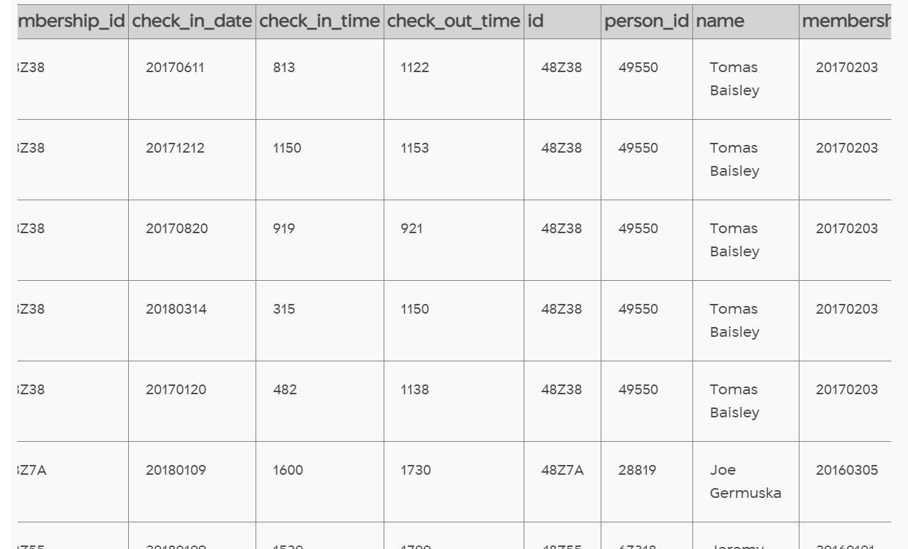

1. Since we have the check in date with us, we are again filtering the data with check in date of January 9th.

Query: SELECT *

FROM get_fit_now_check_in

JOIN get_fit_now_member

ON get_fit_now_check_in.membership_id=get_fit_now_member.id

WHERE membership_id

LIKE "48Z%"

AND check_in_date=20180109

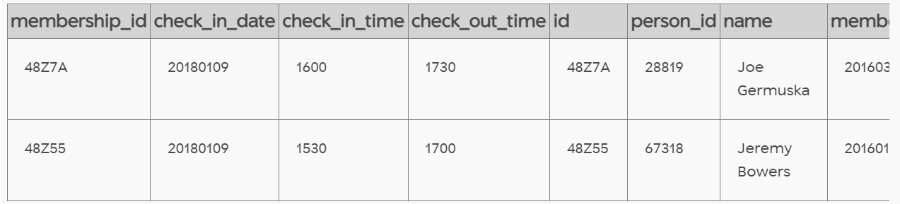

1. Since, we have two suspects here, we insert both there names in the solution box and find out who the culprit is.

Query: INSERT INTO solution VALUES (1, 'Jeremy Bowers');

SELECT value FROM solution;

We found Jeremy Bowers as the culprit.